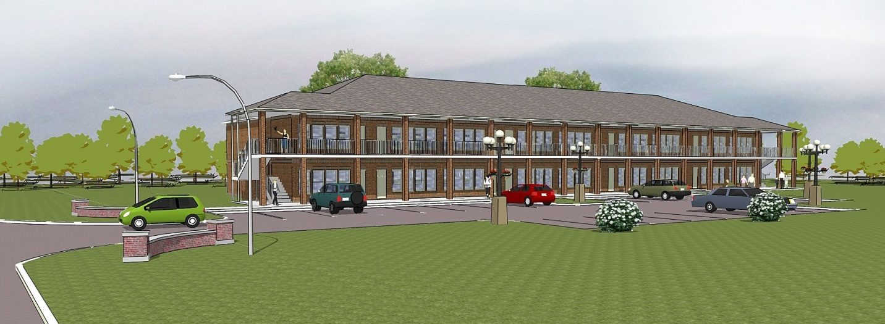

Coming August 2013

**ASHLEY MANOR APARTMENTS**

**925 East 17th Avenue**

*ONE BEDROOM, ONE BATH*

*AFFORDABLE LUXURY APARTMENTS*

* Total electric with central heat & air.
* Security system included.
* Fully equipped kitchen includes refrigerator with ice maker, range/oven, dishwasher, above range microwave & garbage disposal.
* Each apartment has its own laundry room with washer & dryer connections.
* Granite countertops in kitchen & bath.
* Hardwood floors.
* Ceramic Tile in baths.
* Ceiling fans.
* Two inch Blinds.
* Monthly pest control provided.
* On-site garbage dumpster provided.
* 24 hr Emergency Maintenance.
* Just ¼ mile to University of Alabama – easy drive, no train wait!

$695.00 per month

**DELVIEW PROPERTIES, LLC**

711 Black Bears Way 205-345-4600

[www.delview.com](http://www.delview.com) rent@delview.com